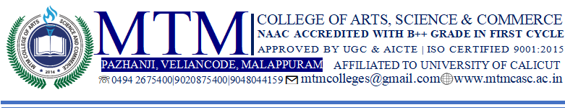

**Entrepreneurship Development Club**

**2024 - 2025**

1. **Workshop on seed pen Making**

The Entrepreneurship Development Club of the Department of Commerce & Management Studies, in association with IQAC, organized a Workshop on Seed Pen Making on 5th June 2024. The workshop was coordinated by Syam Prasad AV, Coordinator of the ED Club, and attended by 30 students. The main objective of the workshop was to introduce students to the concept of eco-friendly seed pens and to promote sustainable alternatives to plastic pens.

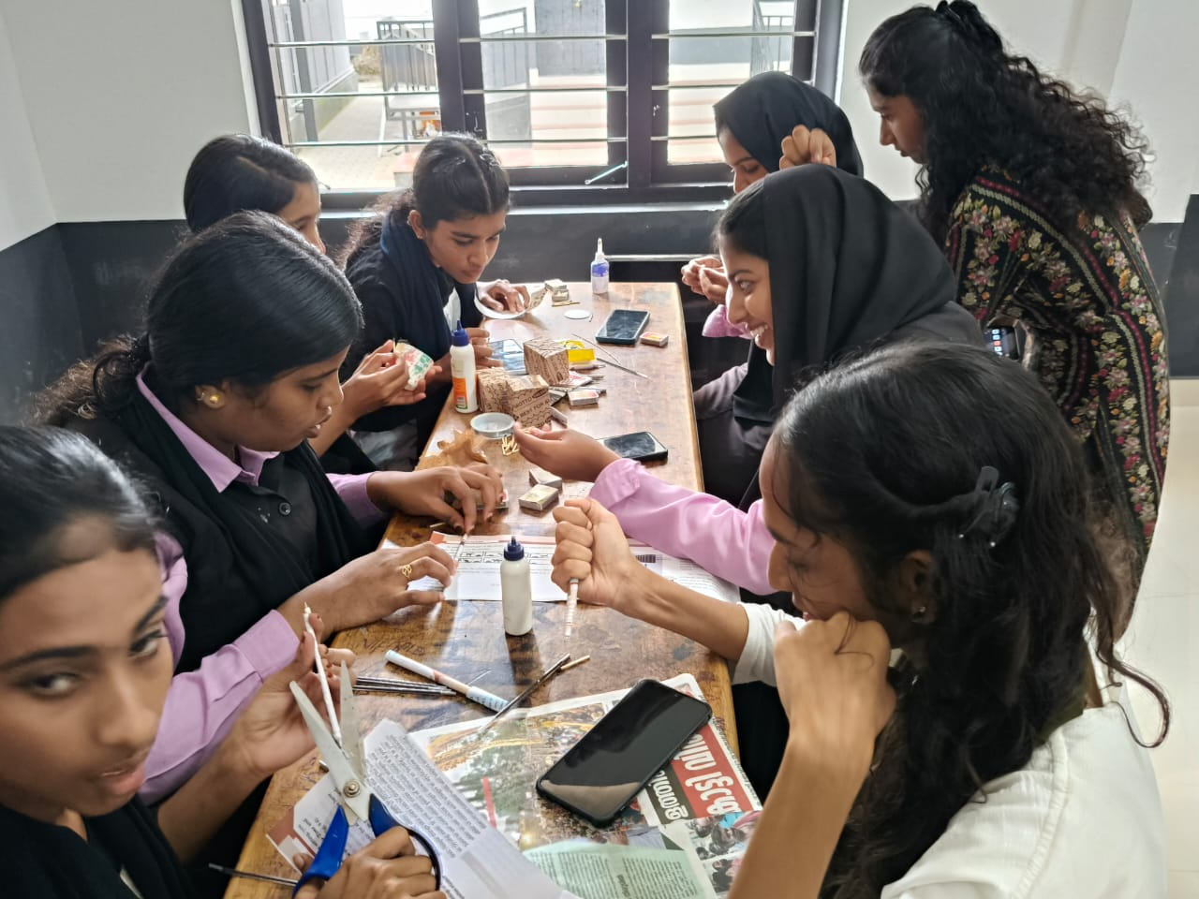

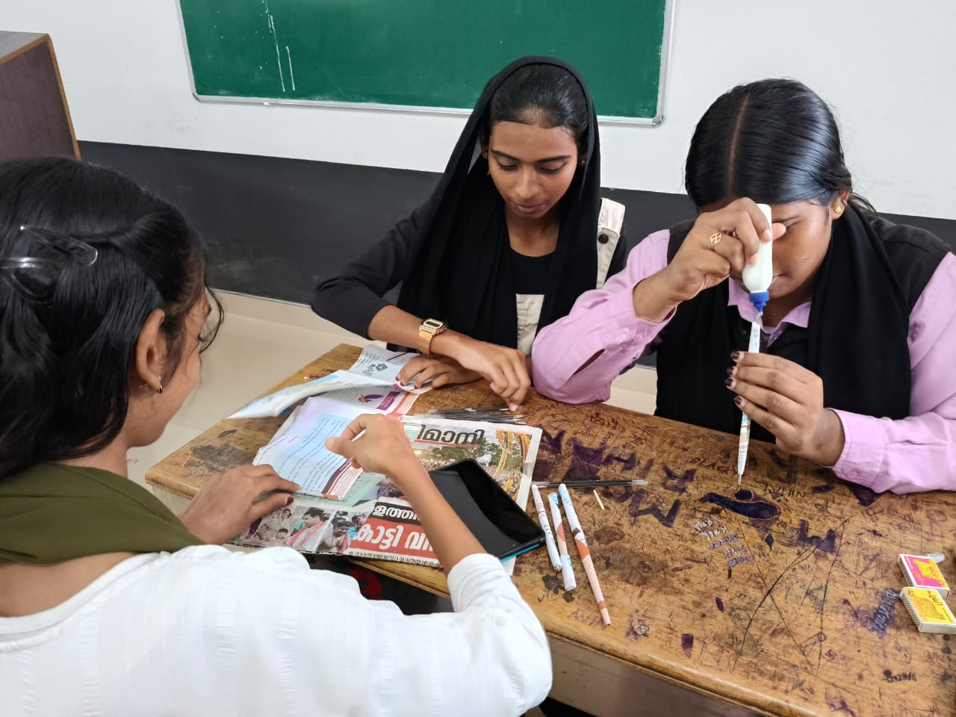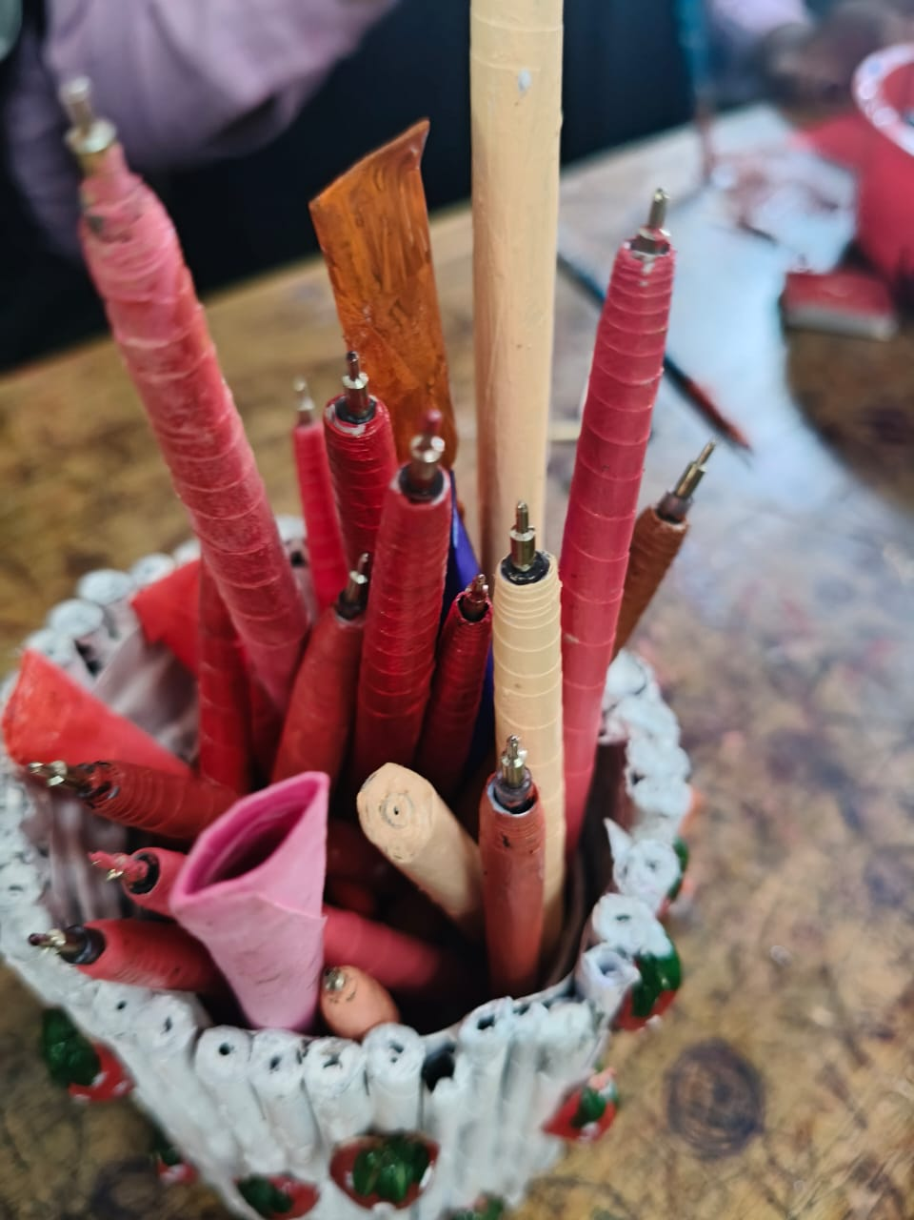

1. **WORKSHOP ON BOTTLE ART.**

The Entrepreneurship Development Club and the Department of Commerce, in association with IQAC, organized a "Workshop on Bottle Art" on July 8, 2024, as part of the academic year 2024-25. The workshop aimed to encourage students to explore their creativity and learn the art of decorating bottles for decorative and commercial purposes. The event was coordinated by Syam Prasad A V, Co-ordinator of the ED Club, and witnessed the enthusiastic participation of 25 students.

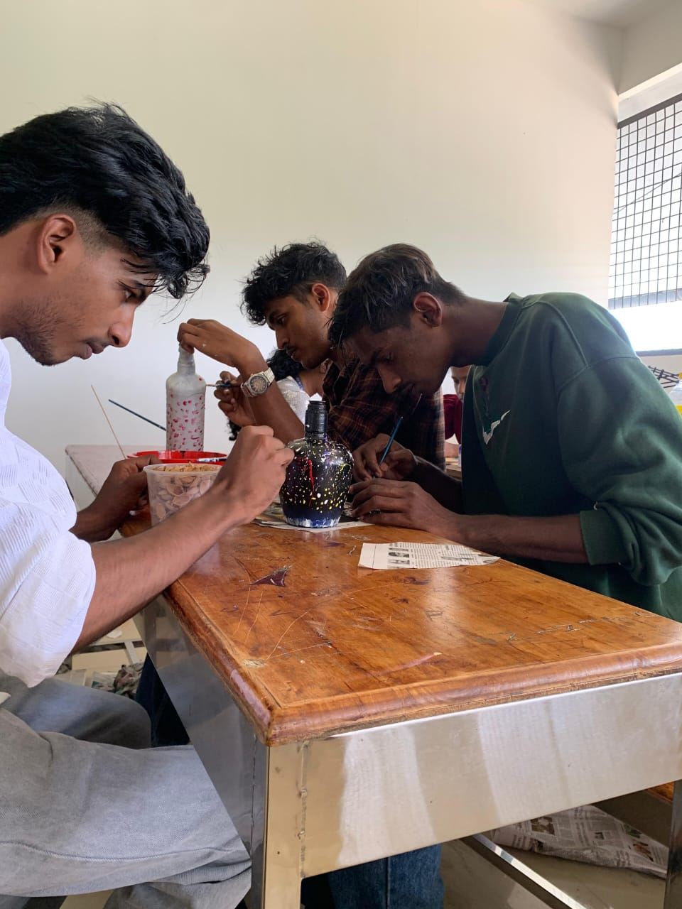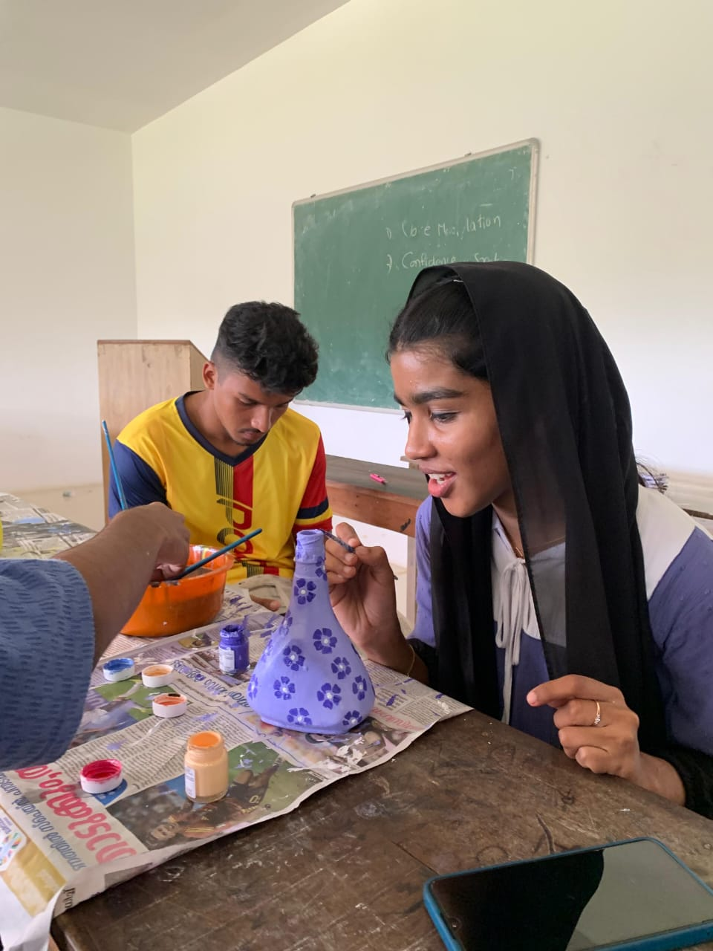

**3.WORKSHOP ON UMBRELLA MAKING**

The Entrepreneurship Development Club (ED Club) of the Department of Commerce in association with IQAC, successfully organized a Workshop on Umbrella Making on 9th August 2024. The event aimed to impart practical skills in umbrella making, encouraging students to explore entrepreneurial opportunities in handicraft production. The workshop was coordinated by Mr. Syam Prasad AV, the ED Club Coordinator, with active participation from Vidya, S5 B.Com Cooperation students, who played a vital role in guiding and assisting participants in the process of making umbrellas. A total of 30 students enthusiastically took part in this hands-on learning experience.

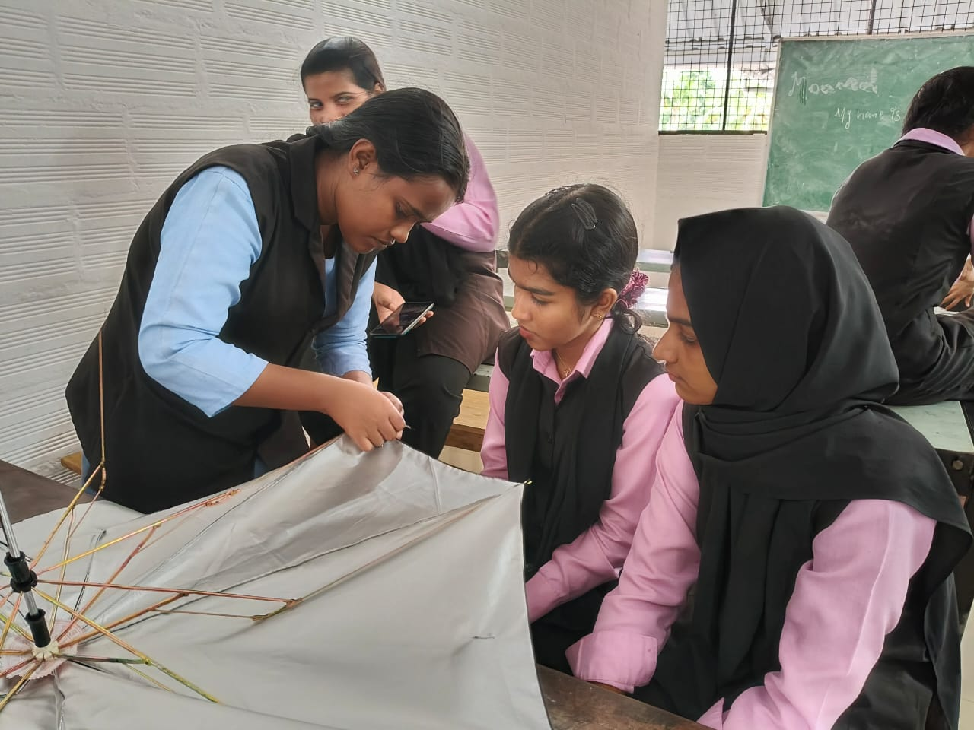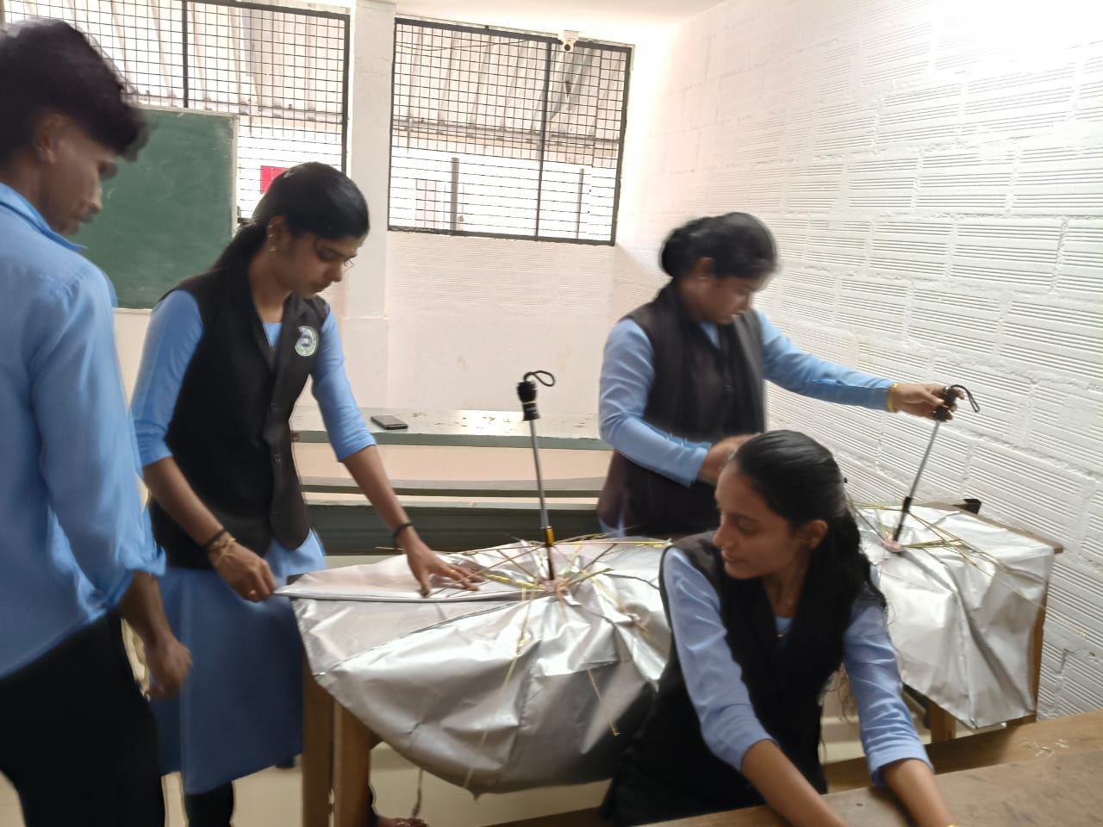

**4.WORKSHOP ON PAPER CRAFT**

The Entrepreneurship Development Club, in association with IQAC, organized a Workshop on Paper Craft on 13th August 2024. The workshop was coordinated by Syam Prasad A.V., Coordinator of the ED Club, and was attended by 20 students. The main objective of the workshop was to introduce students to the art of paper crafting, enhance their creativity, and teach them different craft techniques. The session also aimed to promote the use of eco-friendly materials, develop patience and concentration, and explore paper crafting as a potential hobby or business opportunity.

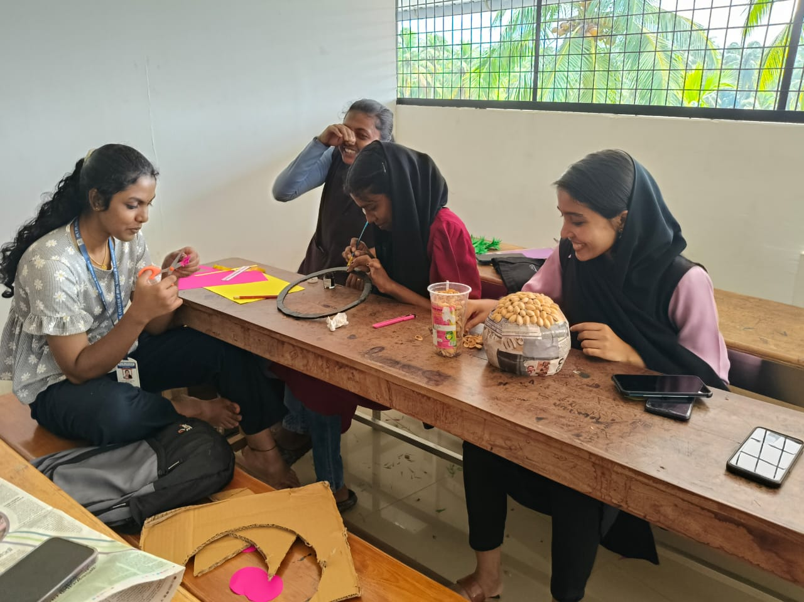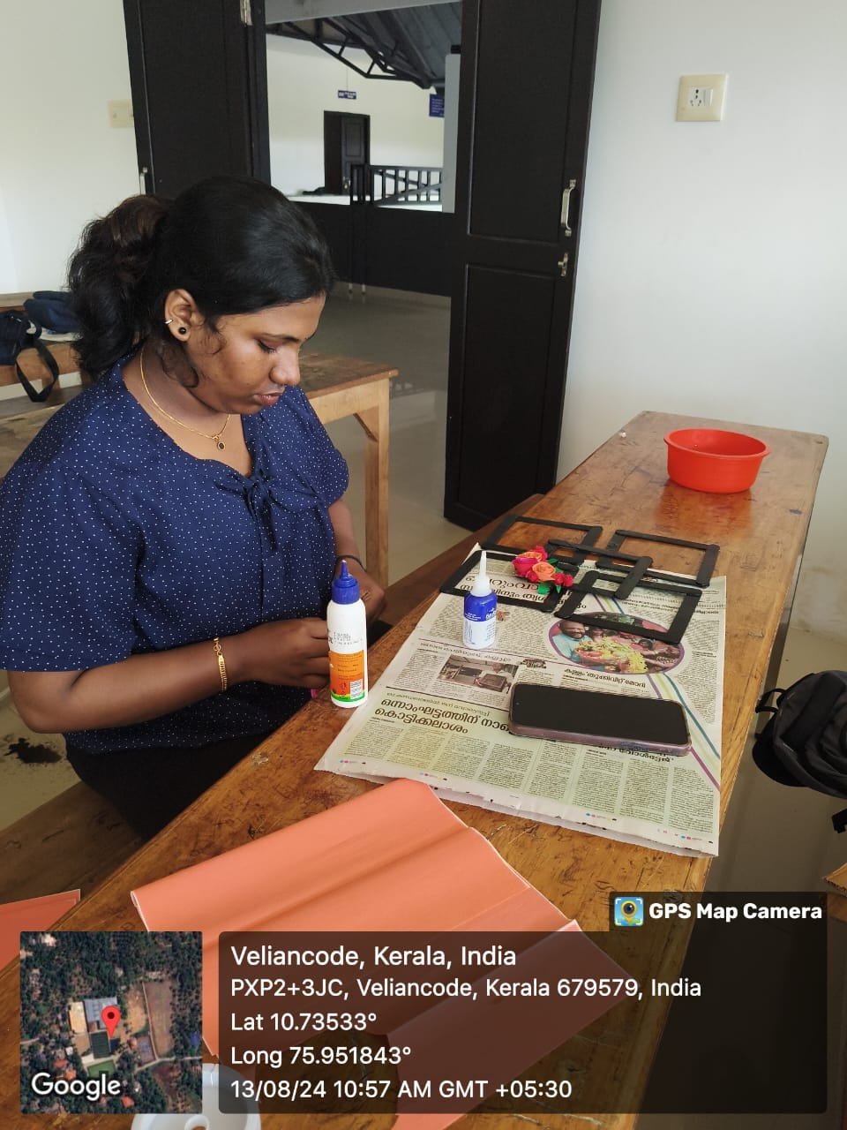

**5. WORKSHOP ON PHENOL MAKING**

The Entrepreneurship Development Club, in association with the Department of Commerce and IQAC, organized a “Workshop on Phenol Making” on August 19, 2024. The workshop aimed to teach students the process of making phenol and encourage them to explore self-employment opportunities in household cleaning product manufacturing. The event was coordinated by Syam Prasad A V, Co-ordinator of the ED Club, and was attended by 22 enthusiastic students.

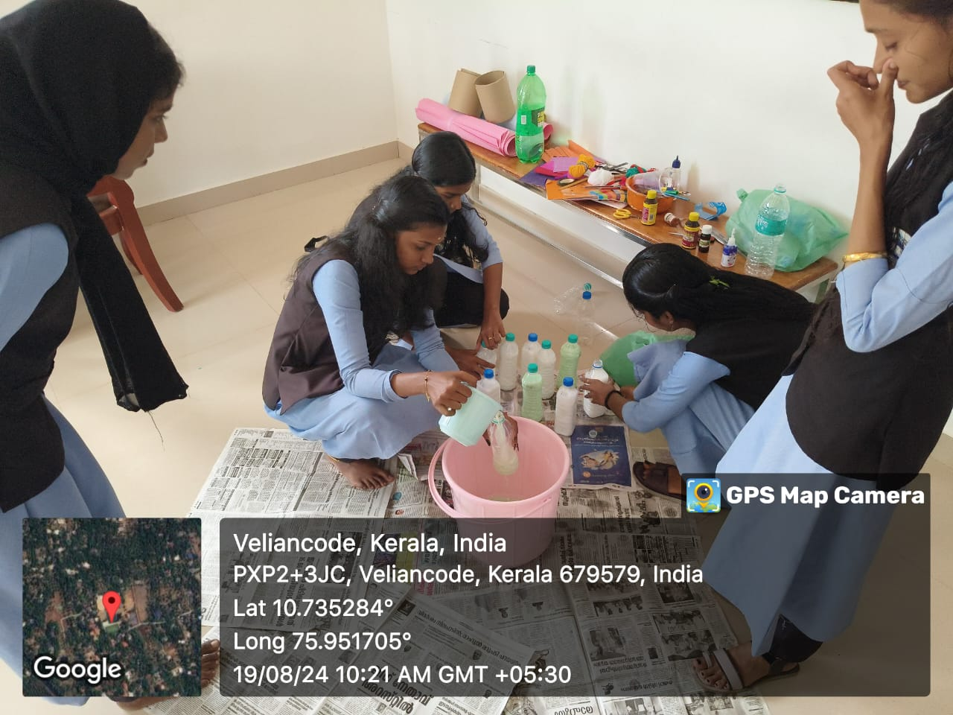

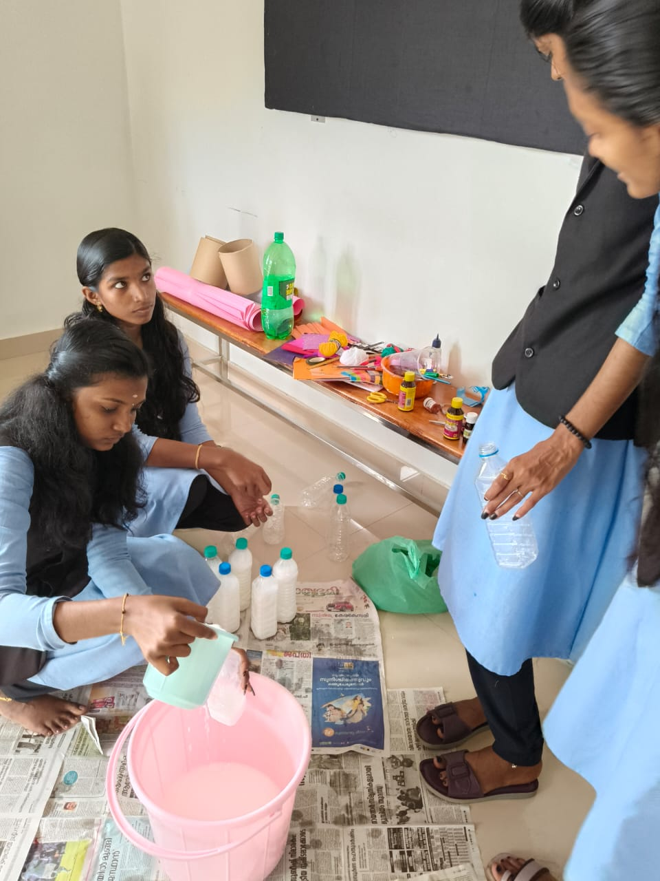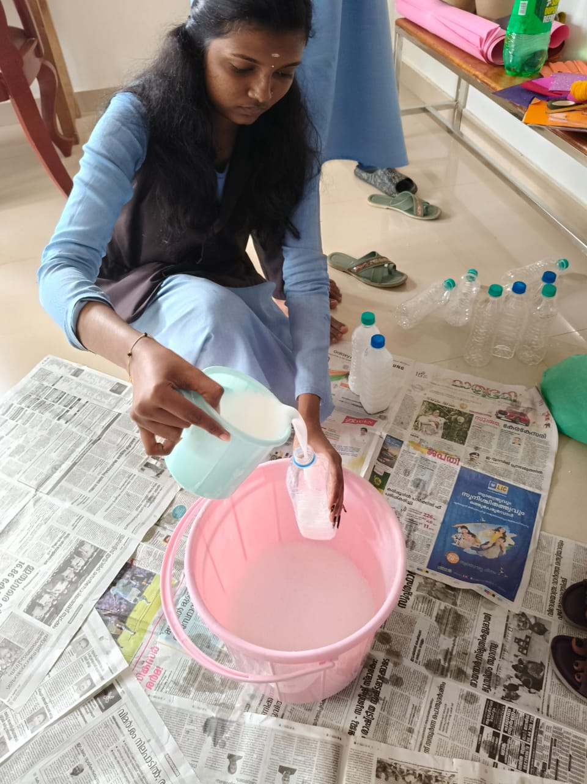

**6.WORKSHOP ON AGARBATHI MAKING**

The Entrepreneurship Development Club, in association with IQAC, organized a Workshop on Agarbatti Making on 15th November 2024. The workshop was coordinated by Syam Prasad A.V., Coordinator of the ED Club, and attended by 27 students. The main objective of the workshop was to teach students the process of making agarbattis (incense sticks), introduce them to the basics of small-scale manufacturing, and explore the potential of agarbatti making as a business opportunity.

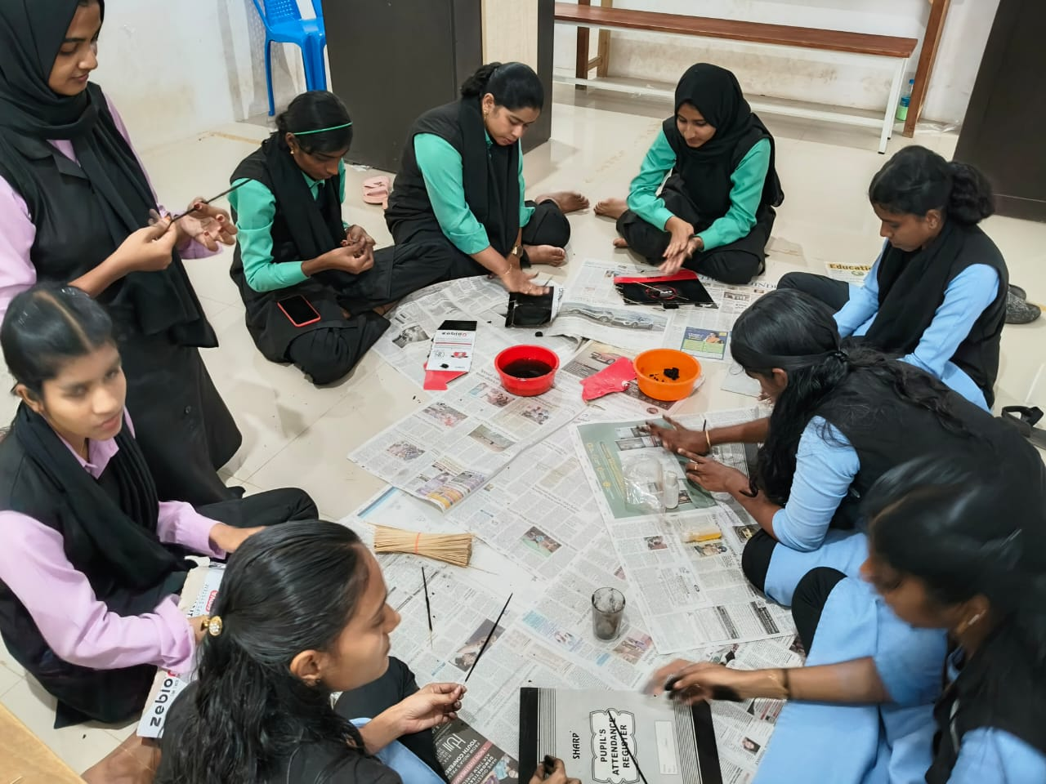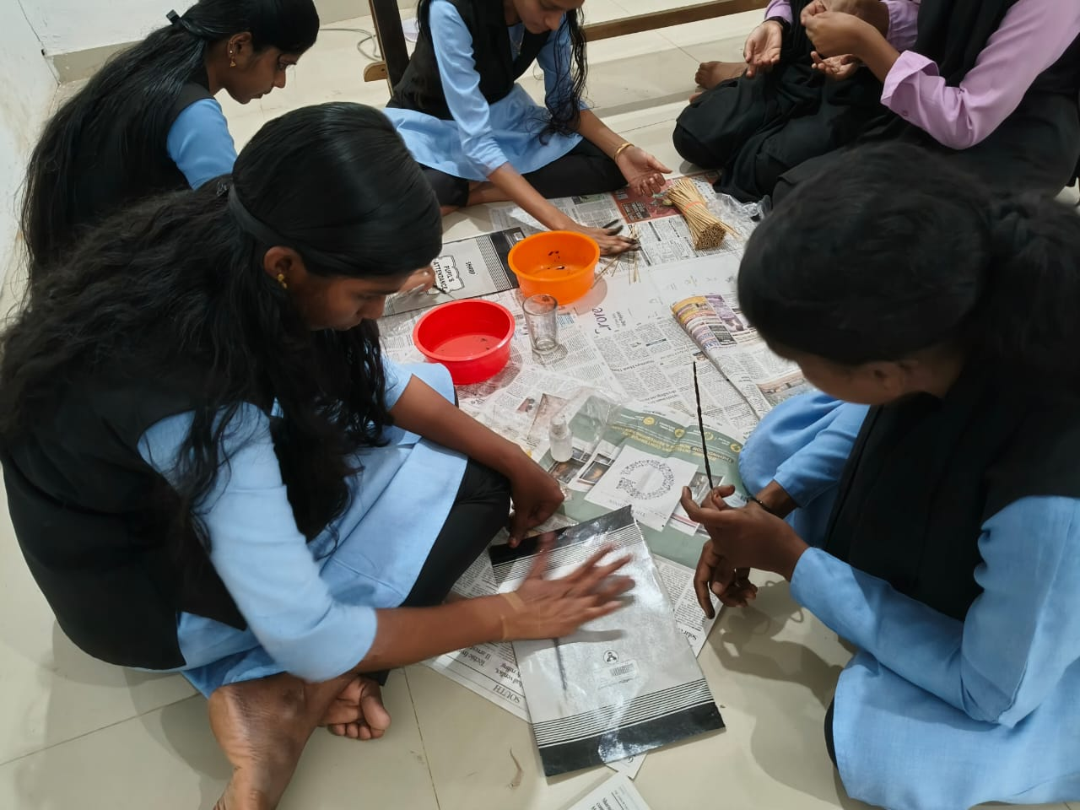

**7. WORKSHOP ON LED BULB ASSEMBLING**

The Entrepreneurship Development Club, in association with the Department of Commerce and IQAC, organized a “Workshop on LED Bulb Assembling” on October 28, 2024. The event aimed to equip students with practical skills in assembling LED bulbs and create awareness about energy efficiency and entrepreneurship opportunities in the LED industry. The workshop was coordinated by Syam Prasad A V, Co-ordinator of the ED Club, and was attended by 27 enthusiastic students.

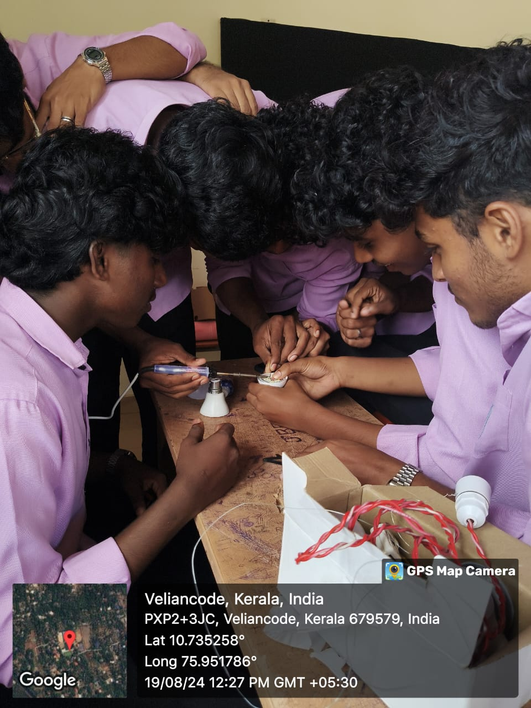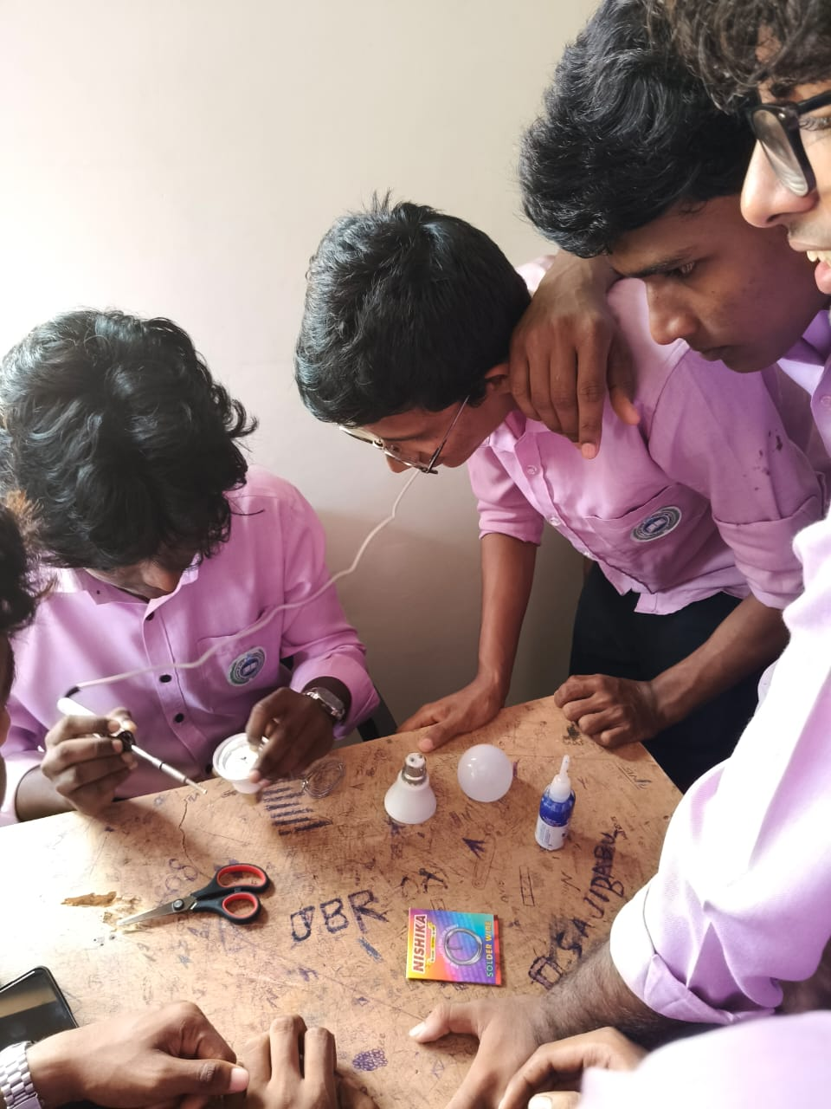

**8. WORKSHOP ON CHALK MAKING**

The Entrepreneurship Development Club, Department of Commerce, in association with IQAC, organized a Workshop on Chalk Making on 11th November 2024. The workshop aimed to provide hands-on training to students on the process of manufacturing chalk, a low-cost and highly useful product widely used in educational institutions. The event was coordinated by Mr. Syam Prasad A V, Coordinator of the ED Club, and was exclusively conducted for the ED Club members.

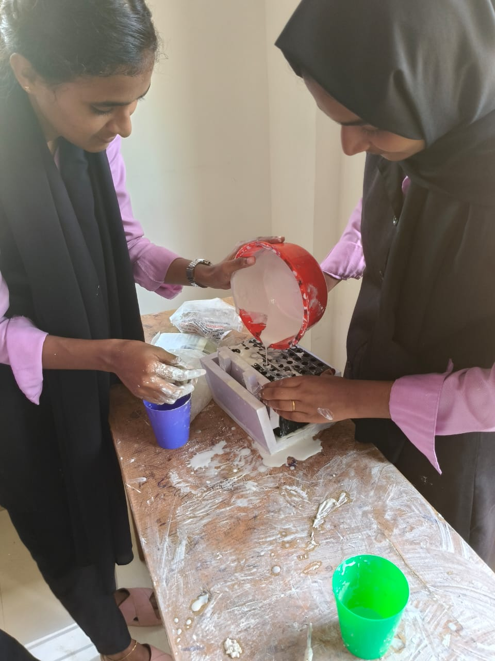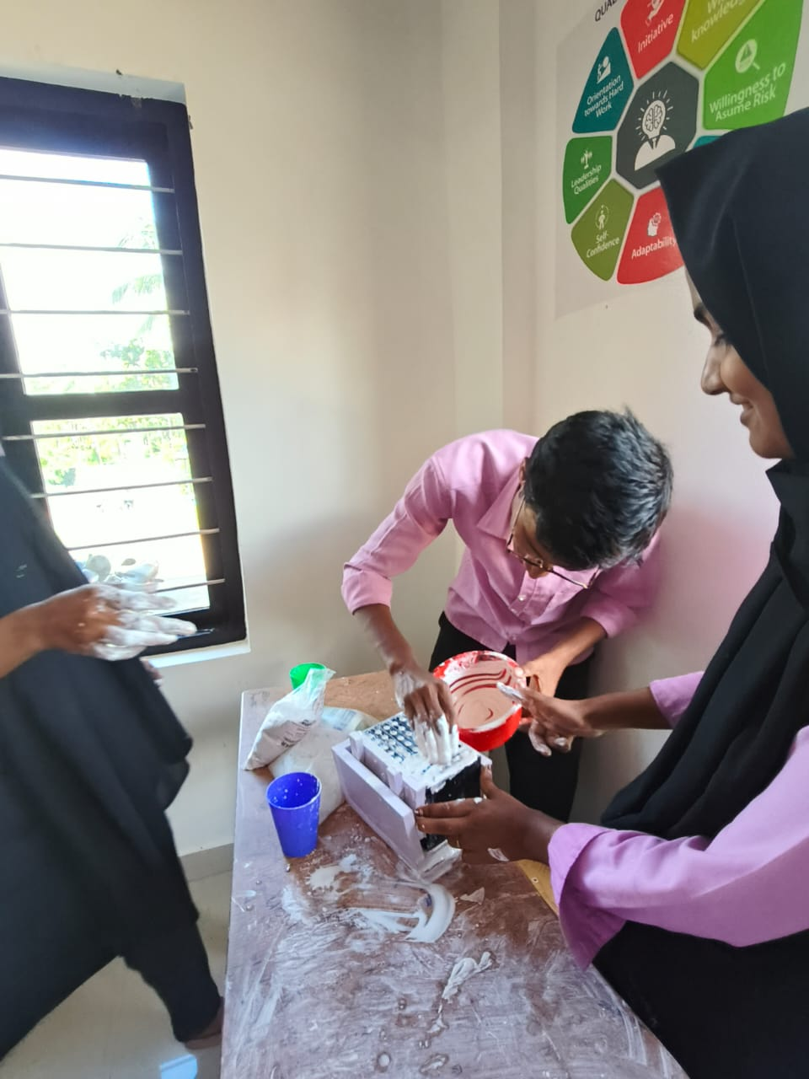

**9. WORKSHOP ON STITCHING SKILLS**

The Entrepreneurship Development (ED) Club, in association with IQAC, organized a "Workshop on Stitching Skills" on January 3, 2025, with the aim of equipping students with essential stitching techniques. The workshop was specifically designed for ED Club members, and a total of 20 students participated in the event. Syam Prasad A V, Co-ordinator of the ED Club, led the program, ensuring its smooth execution.

